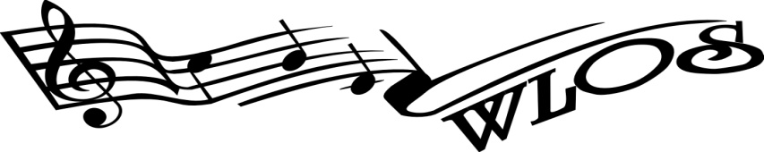 **PO Box 3472, Wokingham RG40 9AL**

General enquiries telephone – 07388 838 455

**www.wlos.co.uk – enquiries@wlos.co.uk**

## Woodley Light Operatic Society Membership Form

|  |  |  |  |
| --- | --- | --- | --- |
| **Name** |  | | |
| **Address** |  | | |
|  | | Post Code |  |
| Mobile |  | Home Tel |  |
| Email |  | How did you hear about WLOS |  |

|  |  |  |
| --- | --- | --- |
| **TYPE** | **ANNUALLY** | **SHOW FEE (per show)** |
| Standard | £50 | £50 |
| Senior Citizens | £40 | £40 |
| Students / unemployed | £40 | £40 |
| Non-Acting | £10 | N/A |

Subscriptions:

Please tick box below to indicate payment method

I am paying by cheque payable to **Woodley Light Operatic Society.**

I am paying by BACS. Account no. 01922295 Sort Code 30-91-11.

Please use membership or show fee and your name as the ref and email [membership@wlos.co.uk](mailto:membership@wlos.co.uk) and treasurer@wlos.co.uk to notify them you have paid on line

I am paying by CASH

For further details please contact the Membership Secretary at [membership@wlos.co.uk](mailto:membership@wlos.co.uk), or visit the WLOS website at [www.wlos.co.uk](http://www.wlos.co.uk) . Please notify Committee of any change of name or address

Show or rehearsal photographs may be used for publicity purposes, if you do not wish to have your photograph published please notify the Secretary ([secretary@wlos.co.uk](mailto:secretary@wlos.co.uk))

# Auditioning Information

If you wish to audition for a part in a WLOS production, you must either be a fully paid-up member of the society, or you can pay a £10 audition fee, which is then deductible from the membership fee if you decide to join. Please note that you should submit your audition slip in advance of auditions.

For further Tips on Auditions please visit the WLOS website – [www.wlos.co.uk](http://www.wlos.co.uk)

**Gift Aid**

Declaration:

I would like Woodley Light Operatic Society (reg charity no LP272166AIR) to treat all membership subscriptions and other donations I have made and other donations I make hereafter to be treated as Gift Aid Donations.

I confirm that I am UK tax payer who pays an amount of income tax or capital gains tax at least equal to the tax the society reclaims on my subscriptions and / or Donation each year.

Date______________________ Signed______________________________

NB: You can cancel this declaration at any time by notifying the WLOS Committee

Please notify the Committee of any change of name or address

P.T.O.

Social media behaviours

It is important that members understand that their comments and actions on social media sites may be seen by a wider audience and that their activities may damage the reputation of WLOS as well as affect relationships with members and WLOS audiences.  Inappropriate use of electronic communication systems can result in material financial loss and/or legal action being taken against us.

For these reasons all our members are obliged to use electronic communications and social media appropriately and responsibly within their personal lives where they have an active link with WLOS.

Unlike informal conversations, comments made online can be permanent. If you include on your profile a link to WLOS, then any other groups you associate with may also be linked to WLOS and this can cause a reputational risk to the society.

This will also apply if you are wearing any promotional show items past or present as your behaviour can be reflected back to the society.

I have read and agree with the above statement

Date______________________ Signed______________________________